

Admissions to Strangford College Outside Normal Transfer Processes (Years 8 – 12)

Summary:

Applications for year 8 are subject to a separate admissions policy and processed via the Education Authority (EA) Online Portal. This EA system remains in place until students are formally admitted to the school, usually 31st August, upon which time this policy comes into place.

Policy Number: 2021/20

Revision: 2

Previous: 2018/13

Board of Governors

Submission for Ratification:

September 2021

**Chairperson:**

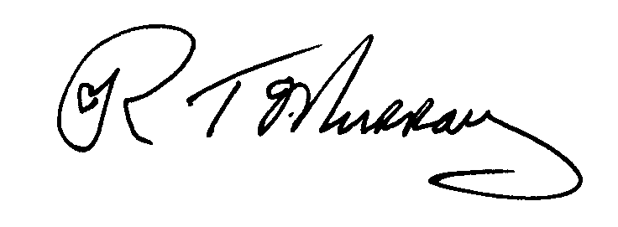

**Principal:**

Description: Clare_Foster

This policy replaces any previous policies and is valid from:

1st September 2021

To be reviewed & updated by: September 2023

By Mrs A Ross



Article 28: The right to an education

**Admissions to Strangford College Outside Normal Transfer Processes**

**(Years 8 – 12)**

**Background**

It is a matter for parents to ensure that all information required by the College to apply its criteria is provided.

Applications for year 8 are subject to a separate admissions policy and processed via the Education Authority (EA) Online Portal. This EA system remains in place until students are formally admitted to the school, usually 31st August, upon which time this policy comes into place.

**Procedure**

To place a child on the College Waiting List, parents should make a written or email request for transfer to the College, and include a copy of the child’s most recent school report. The letter of application should be dated and should clearly indicate the religious affiliation of the child – Protestant, Roman Catholic, or Other. A parent will only be contacted by the College, should a place be available for their child, after the application of the criteria below. Once a child is placed on the College Waiting List, they will remain on it until they are:

1. Offered a place at the College, or,

2. The parent withdraws the application, or,

3. The child reaches the end of compulsory schooling, i.e. the end of Year 12.

**Allocating a place**

When considering the offer of a place, the Board of Governors must work within the overall approved enrolment for the College and will ensure:

A. The necessary resources are available in the particular year group applied for.

B. The Board of Governors must be satisfied that an offer of a place would be in the best interest of the student and the College.

C. Places offered will reflect the maintenance of the religious balance required for an integrated college. The waiting lists will be grouped as Protestant, Catholic or Other. Parents must indicate in the written submission which waiting list they wish their children to be placed on.

D. In the event of a waiting list, when a place becomes available, the following sub-criteria shall apply in the order set down below to the waiting list for the religion identified at C, above.

1. Applicants who presently attend a Grant-Maintained or Controlled Integrated School, as defined in the Education Reform Order (NI) 1989.
2. Applicants, who have a brother, or sister, presently enrolled at the College.
3. Applicant from outside the College’s traditional catchment area, who are relocating to the North Down/ Ards area.
4. Applicants from other schools.

If there is an over-subscription in the last sub-criterion that can be applied, then selection for the available places will be decided on the chronological order of the date on which the initial letter of application was received. Places will be offered, where possible, with reference to maintaining the religious balance of the College. In the event of a tie with the date of applicationa random alphabetical selection will be applied. To ensure no one surname is disadvantaged this random selection is taken from the random selection generated for the current year 8 admissions which is reviewed annually in October.

The Board of Governors reserves the right to seek confirmation of any information supplied.