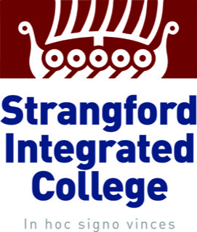

Uniform Policy

Policy Number: 2023/12

Revision: 6

Previous: 2022/12, 2021/26/2

2021/26, 2020/13, 2019/9

Summary:

Our policy aims to set out clearly the uniform that all students are expected to wear at all times in the College.

Board of Governors

Submission for Ratification:

September 2023

**Chairperson:**

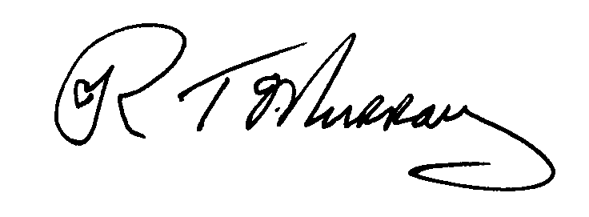

**Principal:**



This policy replaces any previous policies and is valid from:

1st September 2023

To be reviewed & updated by:

September 2024.

By Mrs N Dorrian



Article 3 (best interests of the child) The best interests of the child must be a top priority in all decisions and actions that affect children.

**Uniform**

Uniform plays a valuable role in contributing to the ethos of our College.The Strangford Integrated College uniform gives students a sense of belonging to the Strangford Community. It instills a sense of pride in students for their school and creates an identity for the school in the community.

Acceptance of a place at Strangford Integrated College implies full support and acceptance for the Uniform Policy. We ask you to read this carefully. It is compulsory that students wear the official school uniform at all times during school hours, on journeys to and from school and for official school functions.

The College colours are Maroon, Silver and Black. The uniform consists of:

* Maroon Blazer with College badge
* Four kick pleat grey skirt or black school trousers
* Plain white shirt. Top button should be fastened and shirt tails tucked in at all times.
* House Tie (Clip on)
* Maroon V-neck jumper or Cardigan
* Plain grey socks/black socks with trousers
* ‘Lycra’ Black tights may be worn
* Black leather school shoes (no trainer/canvas style shoes or shoes with visible logos or embellishments are permitted)
* Maroon striped shirt or White short sleeved shirt – Summer Term (optional)
* OPTIONAL school waterproof or a plain black coat. All coats should be worn on top of the blazer.
* A College scarf is available from the school office.

 i) **OPTIONAL** School waterproof or plain black coat. Coats must be worn on top of the blazer.ii) A College scarf is available from the College Office.

No jewellery of **any** kind except a watch is allowed.

No piercings or stud earrings are permitted. Sixth Form students may wear a small pair of stud earrings.

No gel/acrylic nails or nail varnish is allowed.

**Sixth Form Uniform**

* Royal Blue Blazer with college badge
* Four kick pleat grey skirt or black school trousers
* Plain white shirt. Top button should be fastened and shirt tails tucked in at all times.
* House Tie (Clip on)
* Grey V-neck jumper or Cardigan
* Plain grey socks/black socks with trousers
* ‘Lycra’ Black tights may be worn
* Black leather school shoes
* School Sixth form scarf is optional

In Sixth form students may wear a watch and a single pair of stud earrings.

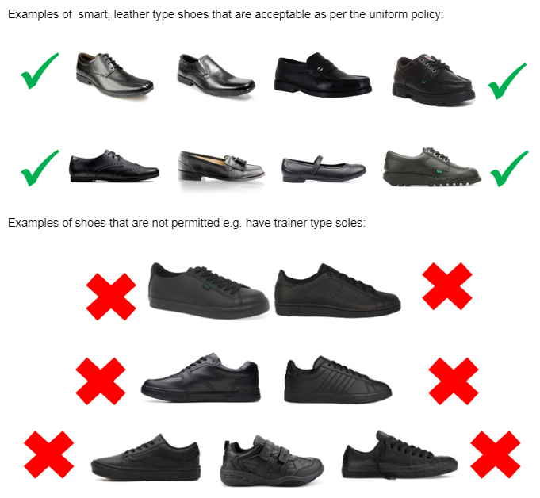

**PE KIT**

**KIT**

The official college PE clothing should be worn.

|  |  |
| --- | --- |
| **COMPULSORY**   * College Polo Shirt or College Rugby shirt * Maroon P.E Skort or Rugby shorts * College tracksuit bottoms * College Socks * Trainers with laces * Football boots (for Football, Rugby and Gaelic) | **OPTIONAL**   * Sports leggings or tracksuit bottoms (Plain black) * College hoodie * College ¼ zip |

Years 8-10 will wear their PE kit on the days that they have PE. Years 11-14 will wear their school uniform and change into their PE kit for their PE lessons. If the need arises the College will put in place reasonable adjustments to cater for individual circumstances.

The following sanctions will be put in place in the event of an infringement of the uniform policy:

* The parent/guardian may be contacted to bring to school any missing uniform.
* When and where possible a replacement item can be temporarily offered by staff.
* Student will remain with their form tutor to complete their classwork.
* A student may be asked to remain at home until the issue is rectified.
* An item may be confiscated (hoodie/jewellery etc). This can be collected by the student at the end of the day. If this is a repeated infringement the parents may have to collect the items at the end of the day.

**STOCKISTS**

FOCUS MENSWEAR Bangor (PE Kit and Uniform)

ROBERTS SCHOOLWEAR Bangor (PE Kit and Uniform)

ALAN ESPEY Newtownards (Uniform Only)

D CRAWFORD Newtownards (PE Kit and Uniform)

SCHOOL DAYS Newtownards (Uniform only)