Google Classroom 101
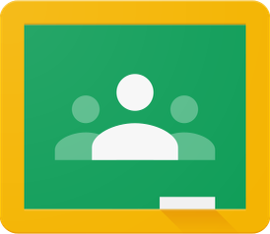

What is Google Classroom?
Many pupils will be encouraged to use Google Classroom as a resource to assist them both in the classroom and at home.

Teachers can use Google Classroom to send announcements to entire classes, share resources, course notes, PowerPoints, diagrams, and homework.

Pupils can use it to access work covered in class in school at home or on the go and complete homework.

Parents can use some of the features of Google Classroom to help engage with and support pupils in their home study. It is a free resource that can be
accessed from any device connected to the internet - laptops, desktop computers, Chromebooks, tablets or mobile phones.

Here is a helpful guide to how to help the student(s) in your family.
Accessing Google Classroom

Pupils can access Google Classroom using the mobile apps (Android and iOS), or via a web browser by visiting www.classroom.google.com .

They should sign in using their school email address e.g. jbloggs123@c2ken.net and the password they use to log in to the school computers.

Once logged in they can view all the classes they are members of, any work set and communicate with fellow classmates. There may not be a classroom for each subject currently.
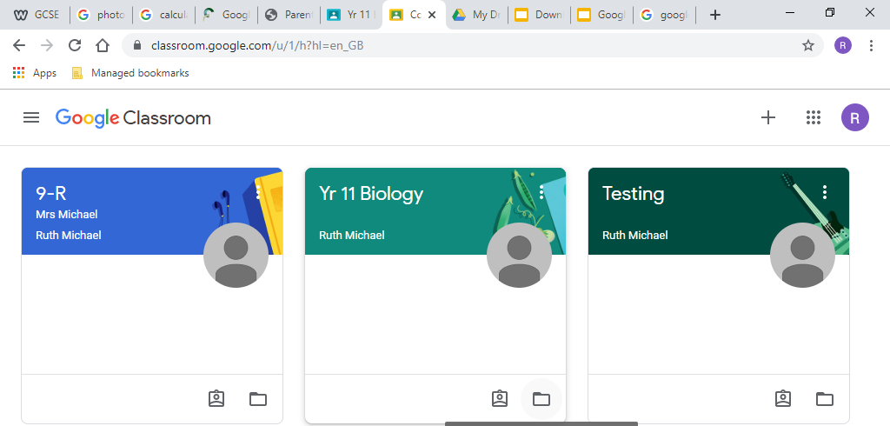
Teacher
Class

The classroom overview page will show any
class announcements, assignments (homework) or posts. The three main views available are:
Stream shows a list of posts made to the classroom by teachers and pupils. This includes announcements, questions and homework/assignments.
Classmates allows users to communicate directly with each other.
About gives an overview of the Classroom and is often where teachers share whole course resources.
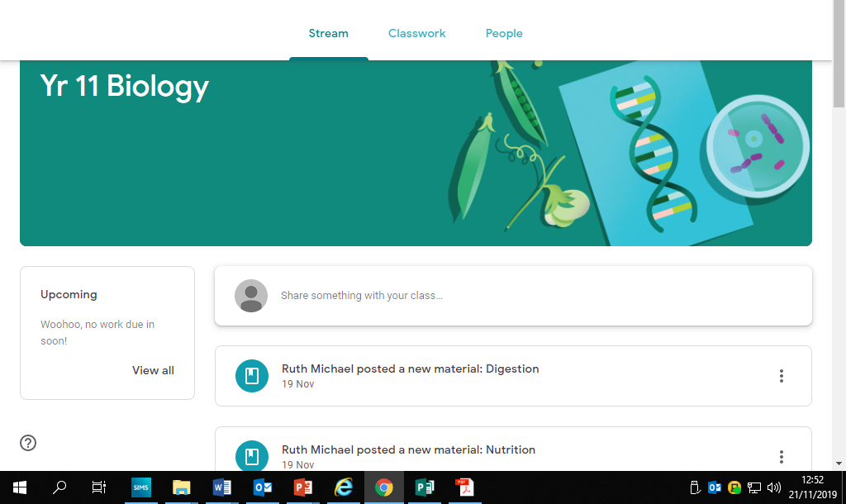

Work that is due is displayed here.

Accessing resources
Google Classroom uses G suite software. To access this on their phone students will need to download the relevant apps (slide, doc and drive) If pupils set up a Google account on their mobile device, their homework due dates, reminders and announcements will all be available directly in their calendar and email.

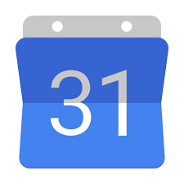
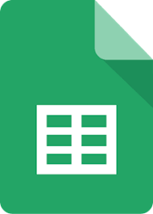
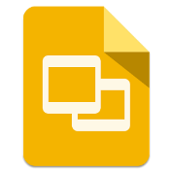
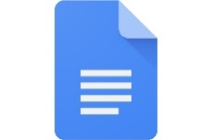

Drive Docs Slides Sheets Calendar

Submitting Homework.

Many teachers are now asking for homework to be submitted online as it enable staff to keep track of late homework and give feedback quicker.

So how do they do it?

This symbol means an assignment has been set.

To submit homework students should click on the assignment.
Select ‘Add or create files’. They can add any file format here.

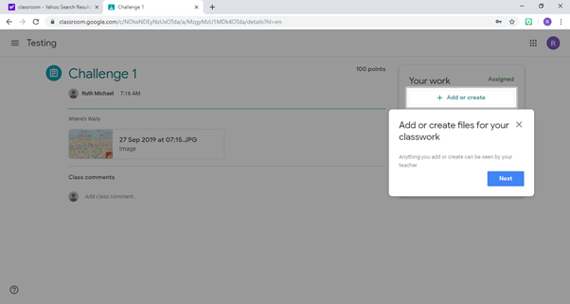

One the document has uploaded just select ‘Turn it in’.
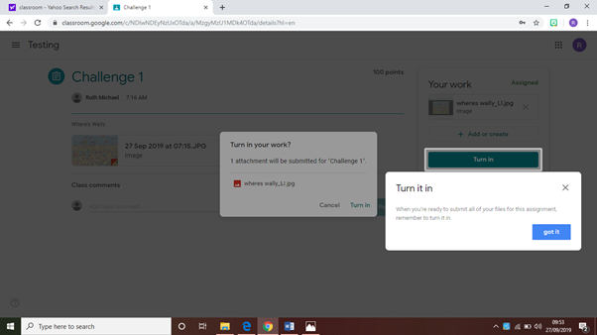

Guardians on google classroom.
As a guardian on google classroom you can receive an email summary to update you on your son/daughter’s progress. In this email you will receive the following information.
- Missing work—Work that’s late at the time the email was sent
- Upcoming work—Work that’s due today and tomorrow (for daily emails) or work that’s due in the upcoming week (for weekly emails)
- Class activity—Announcements, assignments, and questions recently posted by teachers
To become a guardian, you must be invited by the class teacher. Once invited you will receive an email you must accept the invite. You will then be able to decide if you would like to receive daily or weekly emails.
Here are just some of the useful tools that google classroom has to offer!
You can find out more about Google Classroom at https://support.google.com/edu/classroom/
Or feel free to contact myself at the School.
Ruth Michael
Strangford Integrated College
ICT Coordinator

