**How to Log onto School Network from Home.**

The following steps will demonstrate how to Log onto the School Network from home.

1. Using [www.google.co.uk](http://www.google.co.uk) search for the term MySchool
2. Click into the first link which appears in the list- MY-SCHOOL – Login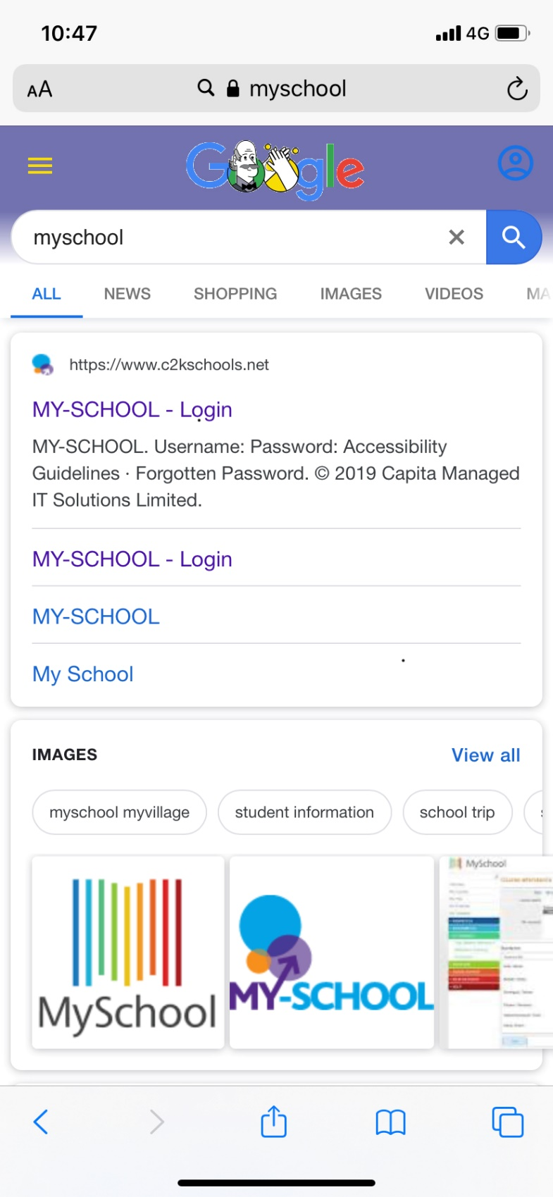
3. Enter your Username in the first Input Box, as you would do so in school, i.e. lmcardle645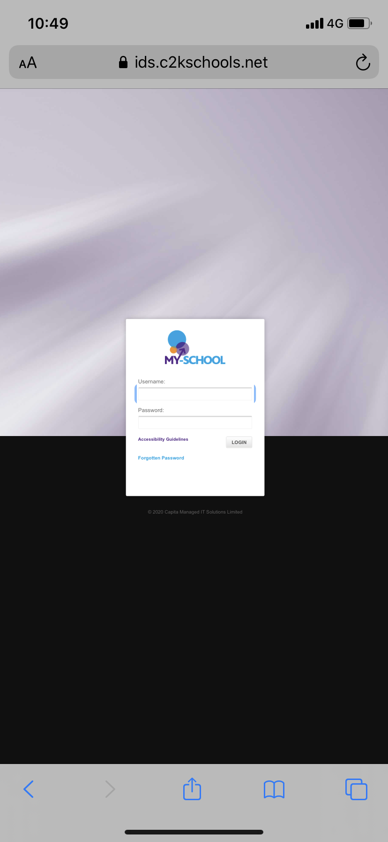
4. Enter your Password in the second Input Box.



1. Click on Log In.



This will now Log you into your School Home Page.

**How to access School folders**

The following steps will demonstrate how to access your school folders and documents from home.

1. With your MySchool Home Page click on the link “View All” within the Applications Panel.



1. Click on “Files and Apps” and click on Launch App under “MyFiles”.

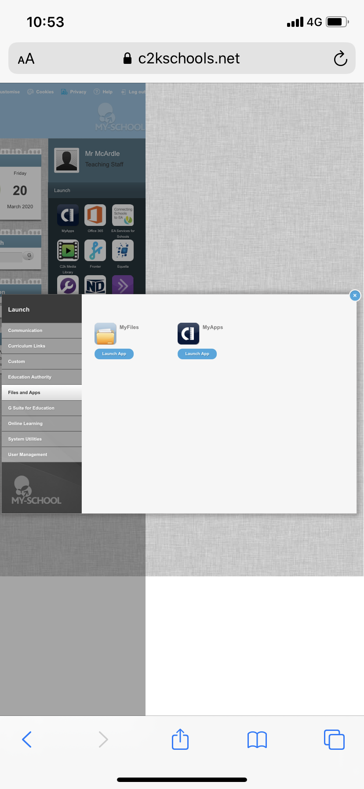

There will be a Lag on your computer whilst the Files and Folders are loading, so please be patient. Once complete you will now have access to your School Folder and Documents. 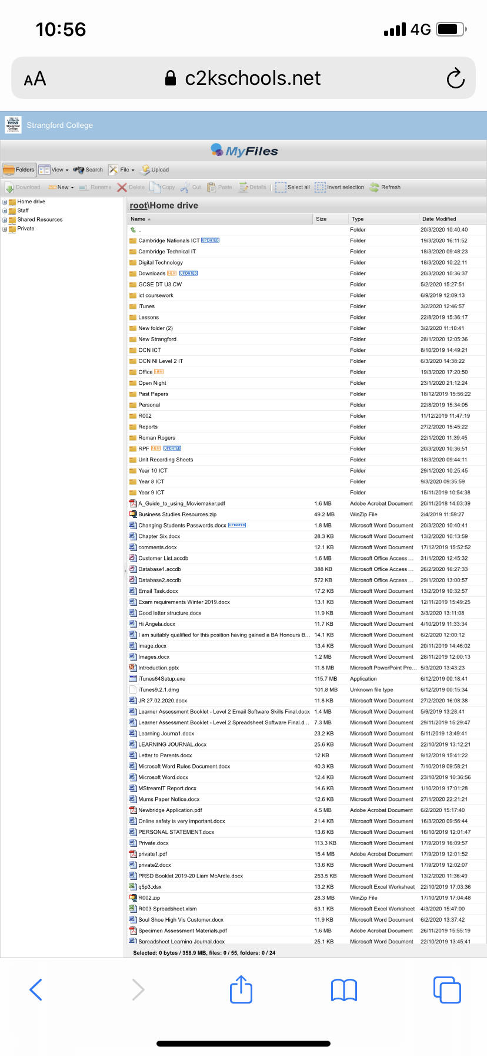

**How to access Shared Documents**

Within your school folders you will have a Menu on the left hand side of your screen called Shared Resources. Double click on this folder to access the school “Shared Resources” folder.



**How to download Microsoft Office at home.**

The following steps will demonstrate how to download Microsoft Office free at home.

1. Within your MySchool Home Page click on the App “Office 365”.

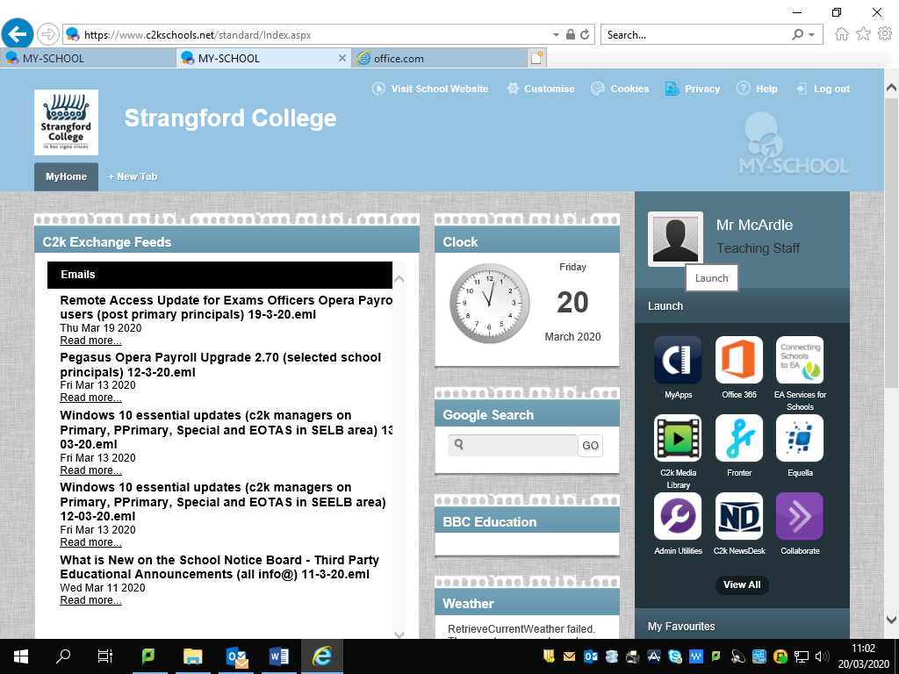

1. Click on the button “Continue to Sign in”.

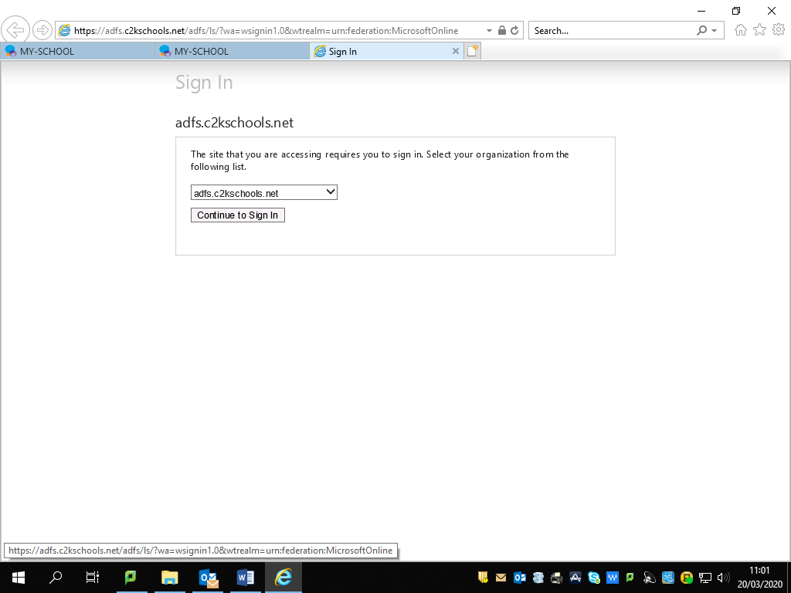

1. This will navigate you to the following page.

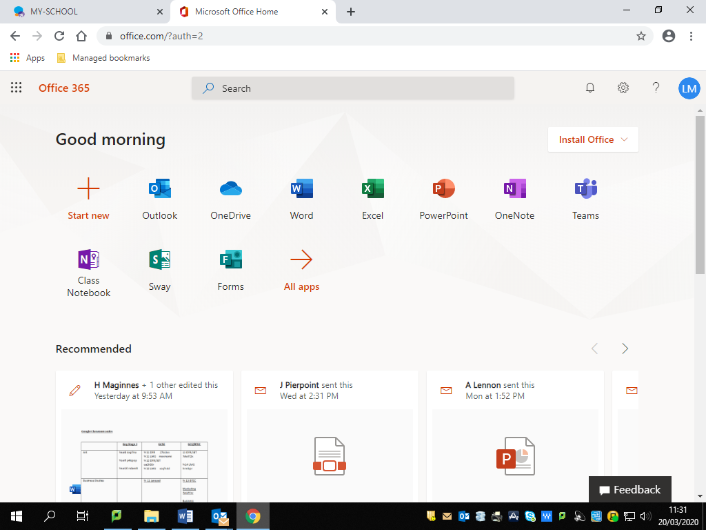

1. To Install Microsoft Office, click on the Install Office link.
2. Select Office 365 Apps

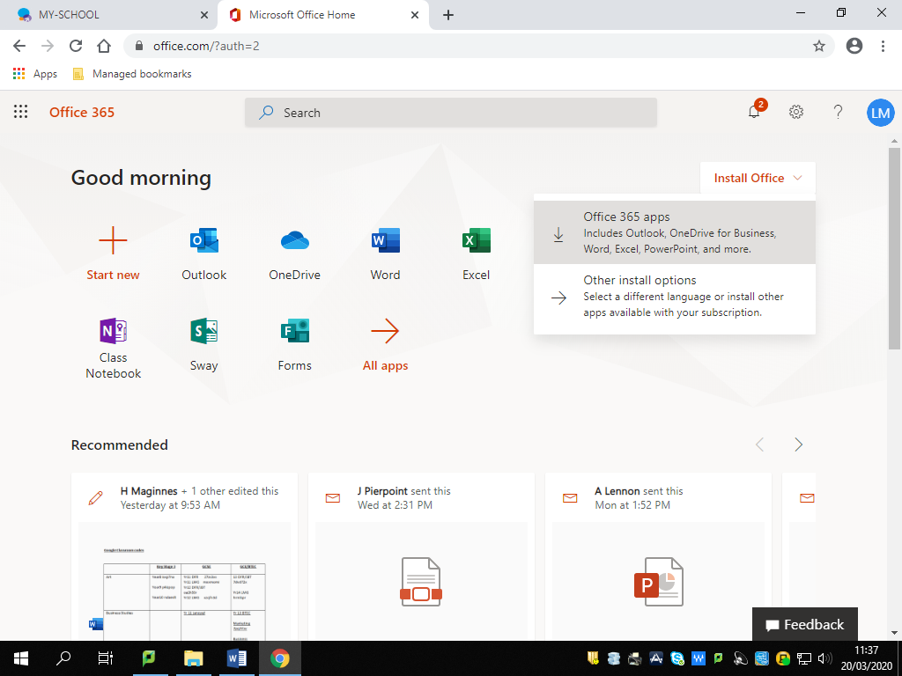

1. Follow the onscreen instructions from here.

