Quarantine - Film Screenplay – How To Guide

A good screenplay does one of the following:

Create conflict immediately | Send your protagonist on a journey

A screenplay follows a rigid layout which is set out
for you in a template on MICROSOFT WORD.

There are SIX key features to a screenplay which includes the following (luckily the Microsoft Word template has it all programmed and formatted for you)!
1 – Slug line – Scene Heading = tells the readers where the scene takes places
- Every scene must have a slugline with two main choices:
  - INT – interior (inside) – EXT – exterior (outside)
- Then you should name the location e.g. bedroom/ living room/ school
- Finally, if relevant, state the time of day e.g. NIGHT / DAY / DUSK / DAWN
2 – Action – Sets the scene and describes the setting and allows you to introduce your characters.
- Ensure you write your action in the PRESENT TENSE.
- Your action should write as things occur e.g. ‘a door slammed shut’ rather than looking back on something ‘a door is slammed shut’.
- You need to describe visually everything that would be evident on screen
3 – Character Name – should be formatted in uppercase e.g. THOMAS – only the first time a new character is introduced. A character doesn't have to have a name they can be a job e.g. TEACHER or a description e.g. AN ANGRY WOMAN.
- When using dialogue a character’s name should be centralised (this is done on Word!)
4 – Dialogue – when a character speaks to themselves, to others, or in a voiceover.
- Do not overuse dialogue in your screenplay – action is key to capturing the essence of your narrative.
5 – Parenthetical – this means to include in brackets; this refers to how the character says or does something
- Generally a parenthetical are ADVERBS (-LY ending words)
- They are useful for capturing a character’s attitude, tone of voice or indicate who they are talking to)
- Parenthetical should be short and focused – and only used if necessary
6 – Extension – placed to the right of a character’s dialogue and included in brackets and captures how the character’s voice is heard by the audience. E.g.
- O.S. – off screen – we hear the character but do not see them on screen.
- V.O. – voiceover – narrator – reflecting and/ or describing something.

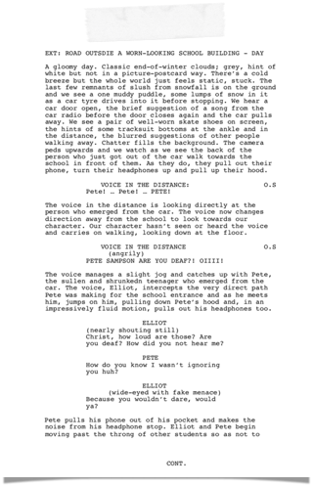
I have annotated the relevant six conventions of a screenplay this an example of an A* script:

SCENE 1:

Slug line: | Remember INT or EXT? - Describe the location – Time of Day?
Action: | A good screenplay will open with a visual depiction of the scene; creating the atmosphere of the screenplay. Try to capture the mood and ensure it establishes the GENRE – teenage film.  You can introduce your MAIN PROTAGONIST (use your stickman to help) try to make sure the description captures the character’s personality and qualities.  Think of how your screenplay will start what will the DIALOGUE be? Will it be from your character? Or an unnamed character? Will it be a OS (it doesn’t have to!)
Dialogue | Remember DIALOGUE should be CENTRALISED and only used if necessary and if it DRIVES the QUEST / JOURNEY / CONFLICT further  A* example – developed and realistic D example – small talk  not interesting, doesn’t grab & hook
Parent-  hetical | Remember to ( ) to capture the MOOD / ATTITUDE / DIRECTED AT  The ADVERBS below should be very helpful:  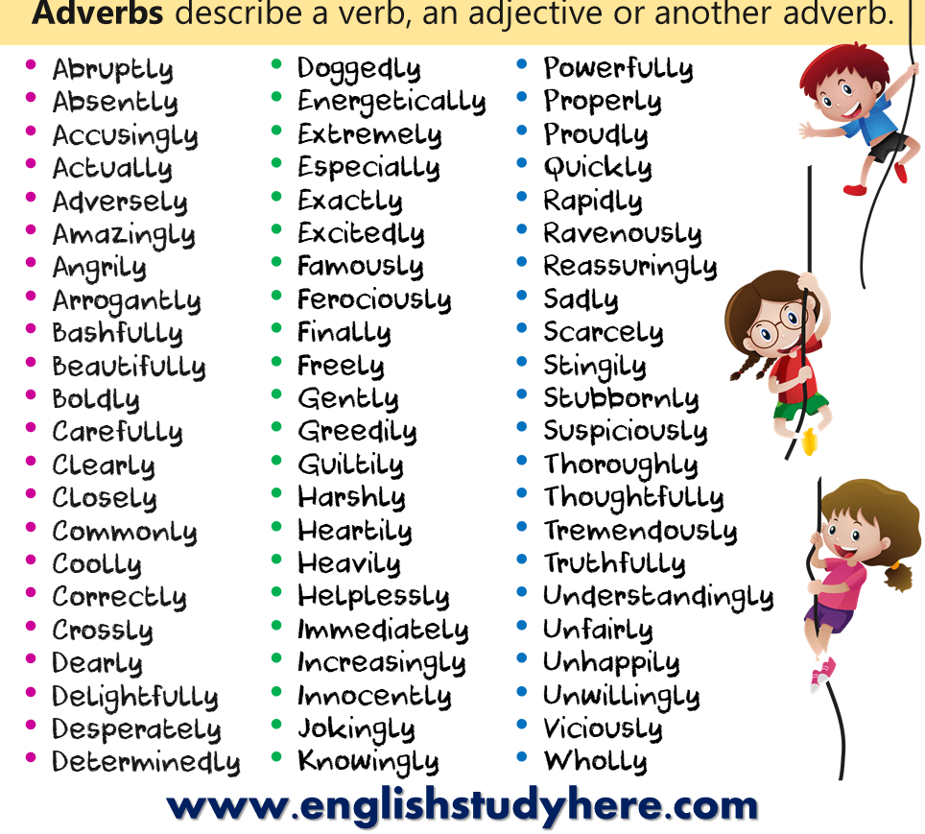  Don’t just use an adverb  E.g. accusingly  INSTEAD  (accusingly and with venom)  ONLY USE IF NECESSARY TO YOUR DIALOGUE and PLOT for your TEEN FILM
KEY POINTS TO REMEMBER: | - Remember to centralise ALL dialogue  - Only use dialogue if it is necessary and drives the narrative forward  - Action is so important – the more action and description the better.  - Good action will describe briefly some of the camera work e.g. the camera pans – BUT only briefly – you want to leave it up to the director to decide the overall cinematograpgy  - Remember to describe the character in your action the first time they’re introduced – try to be creative and capture the essence of your character in their description.
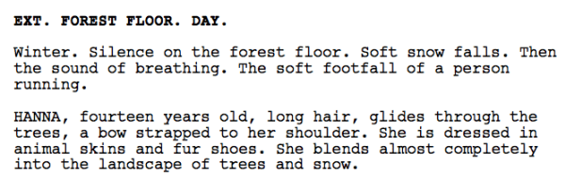
NOTICE: the physical description of character but also:

WEARING?
WHERE ARE THEY GOING?
WHAT’S THEIR ATTITUDE?
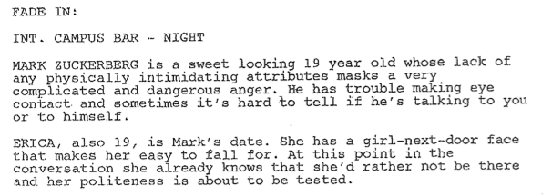
HOW DO THEY CARRY THEMSELVES?
DEADLINE No. 1
SOME EXAMPLES

