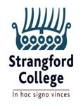

**6Th Form Uniform**

*Strangford College takes pride in the way its students present themselves, particularly the Sixth Form, who set the standards for the rest of the School to follow. Each student should be aware of the following:*

**Clothing**

Sixth form students wear the blue blazer and grey V-neck jumper/short V-neck cardigan and sixth form tie to distinguish them from the rest of the school. All other aspects of clothing remain the same as for Senior and Junior School. Please be reminded of the following:

* Ties should be worn correctly
* Shirts should be tucked in
* Skirts should touch the knee and be the regulation style
* Boys should wear black leather shoes not boots
* Girls should wear low heeled black leather shoes
* Girls should wear black tights or grey socks
* Boys should wear black or grey socks
* Students should blazers at all times
* The only scarf to be worn is the regulation sixth form scarf

Please note students **should not wear-**

**Sweatshirts; Hoodies; Zip-up tops; Black jeans; Trainers; Tracksuit jackets, non-regulation skirts**

**Jewellery**

In the sixth form students may wear 1 pair of single stud earrings, 1 in the lobe of each ear. There should be no other visible piercings. No jewellery or accessories other than a watch will be allowed.

**Hair, Make-up and Nails**

Make- up must appear natural. Hair colour is to be natural looking. Nail polish may be worn if well applied and a nude natural colour. Nail extensions and nail adornment is not permitted and students will be asked to remove these for health and safety reasons. Boys should be clean shaven no shorter than a number 2.

[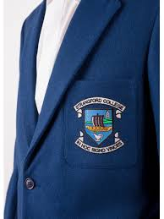](https://www.google.co.uk/imgres?imgurl=https://cdn.shopify.com/s/files/1/2025/8675/products/strangford-6th-2_1024x.jpg?v%3D1503418747&imgrefurl=https://focusni.com/products/6th-year-boys-blazer&docid=njGO4miwCiZzRM&tbnid=VhM404v5V2qzUM:&vet=10ahUKEwix797NlojcAhUIKMAKHTZeCSMQMwhWKBswGw..i&w=1024&h=1365&safe=active&bih=806&biw=1440&q=strangford%20college%20uniform&ved=0ahUKEwix797NlojcAhUIKMAKHTZeCSMQMwhWKBswGw&iact=mrc&uact=8)