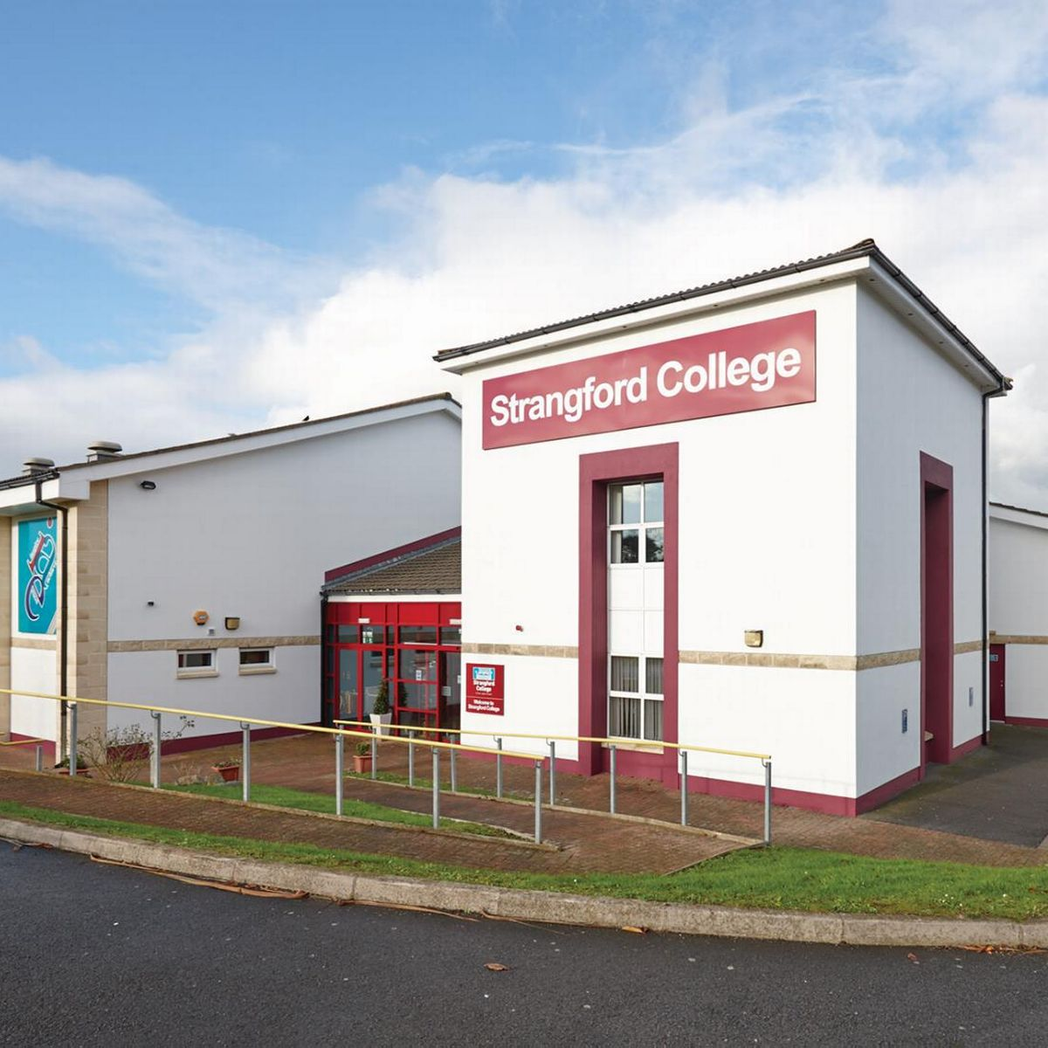

Dear Parent/Carer,

Hello and welcome to Year 10 at Strangford Integrated College.

This year, you will have the opportunity to fine tune your skills across the curriculum, allowing you to build your knowledge and understanding of, not only the subjects on offer for GCSE, but yourself as well. Some of you will come into this year, knowing what you want to work as, and therefore, knowing which subjects you want to study for GCSE. Some of you may believe you know what you want to do and what subjects you wish to study, but will change your mind throughout the year. Others again, will not know what you want to do, and that is fine. As we progress throughout this year, you will begin to investigate what is on offer in the KS4 curriculum as you begin the process of making your choices for next year. What we really must stress is, never rule anything out, you never know what might happen to cause your choices to change.

While choices can be seen as the ‘important’ part of Year 10, we are keen to look towards the bigger picture and not forget about the development of each person as an individual and this can be achieved through any number of ways. We are big advocates for joining as many of the Extra-Curricular Clubs inside Strangford as well as well as trying new sports and organised activities outside of school. These are where you will meet new people and develop new skills.

We look forward to seeing you in the College and wish you all the success for the year ahead.

Mrs K. Newman and Mrs K. Boomer
Joint Head of Year 10

Heads of Year 10

Mrs K. Boomer and Mrs K. Newman

Form Tutors in Year 10

10S – Mr B. Bellinger
10T – Mr H. Thompson
10R – Mr K.Lamont
10A – Ms Diaz Morris
10N – Mr McCartney

Year 10 Pastoral Programme 2023/2024

Year 10 have a varied Pastoral Prgramme in place which allows each pupil to develop both personally and academically. Year 10 is an important year where our young people will make decisions on their future studies and the support they will receive from subject and pastoral teams will assist them to make these decisions.

We have a dedicated and experienced team of Year 10 Form Tutors who will be your child’s first point of call if they need anything or have any questions. Your child will spend the first 15 minurtes each day with their form class and form tutor either in assembly or in form class. During assemblies and form time, students will be spoken to about a range of things including bullying, being kind, coping with change, health and well-being, safeguarding, dealing with disappointment and subject options as well as much more.

Year 10 will all have one period of Form Time on their timetable per week, delivered by their Form Tutor. During these lessons students will study Citizenship, Employability and Personal Development. This lesson will focus on issues such as democracy, crime and the law, skills and qualities that an employer looks for as well as health & the whole person, managing emotions, feelings, managing change, growing up & puberty, self concept and harmful substances. There are lots of opportunities for class discussion, group work and pair work as well as visiting speakers.

As part of the options process, each young person will have the opportunity to meet with one of the Careers team who will support and guide them in the process of selecting their options for study at GCSE. This will also be supported by their Form Tutor, who is available to talk to during form periods. There will be assemblies run by the Careers team to give an overview of subjects available as well as Head of Departments who will introduce some new subjects only available to study at Key Stage 4. We have a dedicated area for Year 10 options on our College website under the ‘Curriculum’ tab. Here, you will find tailored videos for each subject on offer at Strangford Integrated Colege for GCSE. This is a very valuable resource that you and your young person should familiarise yourself with.

Year 10 Monthly Focus

Month | Focus | Thinking Skills & Personal Capabilities
September | Welcome back and standards | - Self Management
October | Friendships and  Kindness | - Working with others
November | Study skills and revision (1) | - Being Creative  - Managing Information
December | Attendance and punctuality | - Self Management
January | Options and GCSEs | - Self Management  - Managing Information
February | Resiliance and personal development | - Self Management  - Being Creative  - Persisting
March | Study skills and revision (2) | - Being Creative  - Managing Information
April | Mental health and wellbeing | - Self Management
May | Teamwork and collaborative learning | - Teamwork  - Being Creative  - Managing Information
June | Study skills and revision (3) | - Being Creative  - Managing Information

Example of Homework Schedules for Year 10

Department | Homework | Duration
Maths | Up to 5 MyMaths tasks per week  Literacy learning homework  End of unit worksheet (every couple of weeks) | 10 mins each  5-10 mins  20 mins
English | 20 mins reading per night  One written homework per week. | 60 – 90 mins per week
French | One homework per week. Learning vocab or written homework | 20 – 30 mins
Geography | One varied homework per week depending on the topic being covered. | 20 – 30 mins per homework
Science | Learning facts  Researching for a topic  Completion of tasks  One homework per week | No time given as each homework will differ
Religious Studies | One per week ranging from finishing classwork, extension activities, quizzes or questions. | 20 minutes max
History | Learning facts  Researching for a topic  One homework per week | 20 – 30 mins per homework

Assessment and Reporting Schedule

Report 1 | Progress report
Report 2 | Progress report
Report 3 | Summer written report

The 4 Golden Rules for Revision

- Plan it – Draw up a revision timetable and stick to it – No excuses give each subject a decent amount of time.
- No noise – best to work in a quiet place and take regular breaks to refresh the mind.
- Break it down – Summarise whole chapters into smaller sections or areas. Use Memory cards or mind maps to help you learn information.
- Highlight – Use colours and symbols to highlight key vital points. Remember key words and phrases by making them stand out on the page.
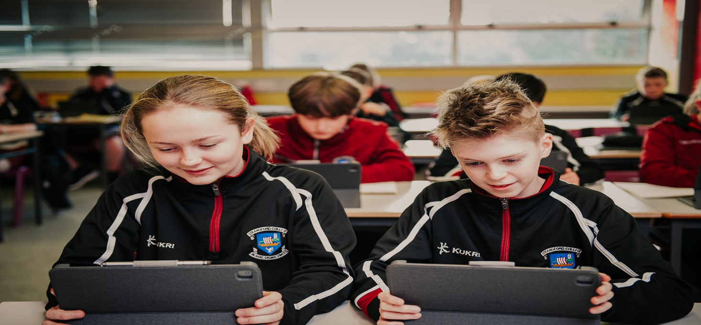

Stepped Consequences Summary

Students, unfortunately, will not always behave in the way we may wish. We will implement the following actions which are two-fold:
- to set an agreed standard of positive behaviour
- to encourage students to reflect on their inappropriate behaviour and learn strategies to avoid such behaviour in the future

The chart below shows guidelines for staff in dealing with incidents. It is not prescriptive as each incident must be considered in context but it should aid with whole - school consistency.
Pro forma should be completed at each stage by relevant members of staff.
Appropriate language must be used at all times by any member of staff involved.
To make the system easy for everyone to understand, we have introduced a set of consequences called C1, C2, C3, C4 and C5 as described below:
**If a parent wishes to discuss a given consequence, they may arrange a meeting with the Head of Pastoral Care, Vice Principal or Principal.
Disruption | Consequence | Guidelines consequences /actions
Low level disruption: e.g. chatting, inattention, lack of work, low level arguing, misuse of equipment/environment, lack of respect, not following instructions, showing off, shouting out answers when not required. | C1  Verbal warning  Dealt with by class teacher | - Name written on whiteboard and verbal warning issued. The student may also be asked to move seat.  - If behaviour improves, no further action will be required.
Persistent Low level disruption:  e.g. continuation of the above, answering back, refusing to follow instructions, failure to produce or complete homework. | C2  Break or lunch time detention  Dealt with by class teacher and monitored by form tutors. | - Name written a second time on whiteboard and recorded on SIMS.  - If a pattern of C2s is evident, the form tutor will initiate a break, or lunch detention to discuss the issues.  - A third incident in class will result in an immediate C3 after school detention.  - If a subject teacher initiates a C3 for class behaviour, they must make a telephone call home by to discuss the cause for concern.  - If the negative behaviour continues after issuing a C3, the class teacher may need to initiate an EXIT.
Failing to adhere to the rules that are set in place to promote safety, good citizenship and effective learning in the College.  e.g.  - Repeatedly not arriving on time  - Repeatedly unequipped for class  - Repeatedly dropping litter and/or not picking it up  - Unacceptable attitude/behaviour  - Persistent uniform infringements  - Failing to report a serious incident, e.g. witnessing damage to school property.  - Inappropriate use of a mobile phone.  - Out of bounds (check map)  EXIT | C3  After school detention  Monitored by  Heads of Year  The decision to initiate a class exit is made by the teacher, and supported by the Head of Dept/Form Tutor. | C3 is when a one hour after school detention. Any member of teaching staff can issue a C3. This may be for behaviour issues inside, or outside, class.  Any member of staff issuing a C3 notifies the office and a record is kept. All after school detentions are taken in the Technology Room from 3.30 - 4.30pm, Monday to Thursday. They are taken in total silence, supervised by the Heads of Year and senior members of staff.  1 Conduct point should be recorded on SIMS  Parents will be phoned, or sent a text message, or email, to inform them that a C3 has been issued. We will assume that parents have received the message we send, even if left on a voicemail. We expect students to attend a C3 instead of any other activity, without negotiation.  If a Student fails to attend a C3, their Head of Year will contact home to ascertain a reason for this. They Student will be given an opportunity to reschedule and re-sit the C3. A second failure to attend will result in a C4 internal suspension.  Heads of Year will receive a weekly summary sheet for C3 after school detentions. Any more than 3, C3 after school detentions per month will result in a C4 internal suspension.  Depending on the seriousness of the behaviour, if C3s have been applied and the student has not chosen to change their behaviour a C5 external suspension may be given.  Students, who disrupt learning persistently, or significantly, will be removed from the classroom. The school office is contacted and the student is escorted to the Head of Year. The automatic consequence is that they will receive a C4 and will spend the following day in isolation.  They will only return to lessons on the day of their Exit if they are deemed to be in the right frame of mind to follow all instructions without further disruption. Any student exited twice in one day, will not return to lessons on that day.  In the event that a student who is not in the right frame of mind to learn and conduct themselves appropriately and whose presence in school may lead to disruption to learning or distress to themselves or fellow students, parent/guardians will be contacted to collect the student for pastoral support.  Students may return to school as soon as they are able with no sanction being set.
Disruption | Stage | Guidelines consequences/actions
This is a very serious consequence. It signifies that the student has made choices that are unacceptable within our community. The withdrawal day gives them a chance to reflect on the choices they have made. Students who misbehave during their time of internal withdrawal will receive a C5 fixed term exclusion, (suspension).  The following may also result in a C4 consequence;  - Truancy  - Being in the company of smokers, carries an immediate C4 consequence. This also applies to the use of e-cigarettes or vaping.  - Being in possession of smoking or vaping paraphernalia on school grounds.  - Vandalism  - Misbehaviour in the school toilets or other areas of the school grounds (depending on the level of misbehaviour, the sanction may be escalated to a C5 external suspension e.g. misuse of a mobile phone). | C4  Internal suspension  Dealt with by Head of Year  Monitored by the Assistant Vice Principal/ Vice Principals | A full day withdrawal from class, under strict supervision.  Students will be required to work in silence and to complete the work that is set.  This is a very serious sanction. The withdrawal day gives them a chance to reflect on the choices they have made.  2 conduct points will be recorded on SIMS.  Students who misbehave during their time of internal withdrawal will receive a C5 fixed term exclusion (suspension).

Serious incident from outset (stages 1-4 jumped) or escalation (may be at other stages but moves quickly to stage 5):  - Serious incident (somebody may be hurt), serious verbal or physical aggression, theft or damage to school property, drugs (which includes tobacco related substances and e-cigarettes), alcohol, or weapons involved with the likelihood that the behaviour will lead to exclusion from the college.  - Persistent infringement of the college rules, where previous sanctions have been applied and the behaviour of the student has not changed. This behaviour is deemed to be unacceptable within the college community.  - Smoking or Vaping on school grounds. | C5  Suspension  Dealt with by Vice Principals / Principal | - Fixed Term Exclusion, followed by re-admission meeting with parents.  - A restorative, meeting will be arranged between the student and a member staff or other students directly affected by the incident.  - This may lead to permanent exclusion. The EA guidelines & College Policy will be followed.  - As at all stages, it is essential that a written account of all actions is kept in the student’s personal file in order that a full and impartial record may be kept.  - A serious C5 incident may result in permanent exclusion from the College. Only the Board of Governors can issue a permanent exclusion.

Positive Behaviour Chart

Here at Strangford College, we believe in positive discipline. We explain the rules and what is expected of our students when they arrive and throughout their time here. Students are all very familiar with our behaviour for learning policy and how this may impact them if their behaviour is not what we would expect.

We are a staff who love to give praise and recognition to our students when they are deserving. Form teachers, subject teachers and other members of staff can award achievement points through SIMS for a variety of reasons such as:
Academic achievement
Excellent effort
Outstanding work
Extra-curricular
Contribution to school values

These achievement points are collated and celebrated in our Rewards Assemblies which are held at the end of each term. Students can win prizes and are recognised by their peers and staff.
At the end of September each year we have the annual Strangford College Prize Night. This is held in the College hall and includes speeches from our Chair of the Board of Governors, our Principal, Head Girl, Head Boy and special guest speaker. There are many prizes awarded on the night for successes such as Sporting achievements inside and outside of school, academic success throughout each subject area for Junior school students as well as for GCSE results, AS results, A2 results. There are also awards for Integration, Resilience and other Special awards given. Parents receive a letter if their child has won a prize so they can attend the prestigious evening and be rewarded for their hard work.
We believe that all students should be praised and rewarded for their efforts and achievements, and we also love to hear about anything our students achieve outside of school.

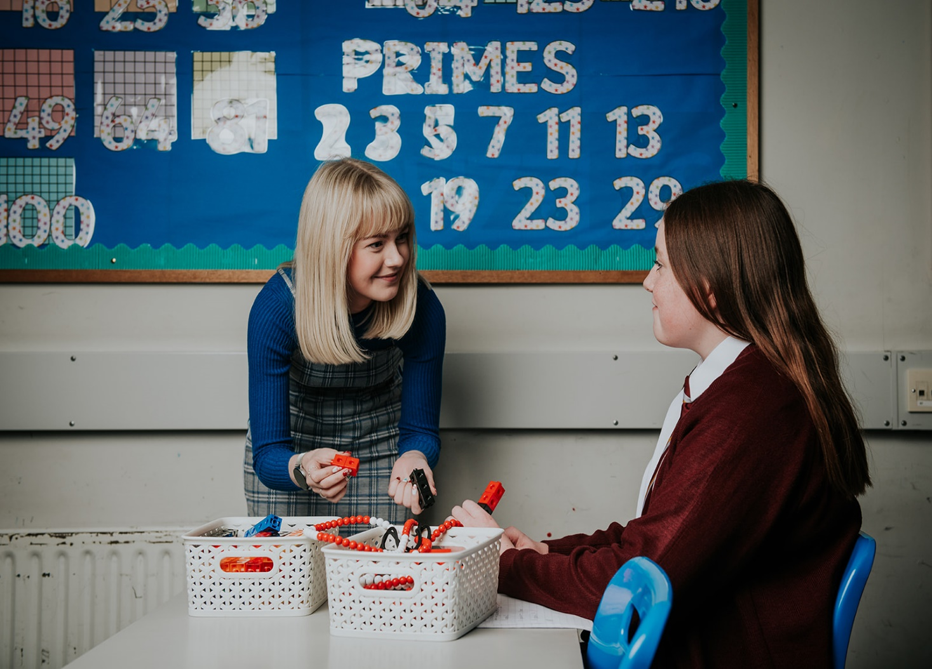

Subject | Head of Department | Overview
English | Mr McCartney | We aim to consolidate skills in Reading, Writing and Talking and Listening. Students study Shakespeare's 'Romeo and Juliet', complete a focused poetry analysis, and explore themes and characterisation in a modern prose text. The study of multi-modal texts and an introduction to the analysis of spoken language texts also form part of the Year 10 curriculum.  - Tasks and assessments are based on the Communication Levels of Progression at Key Stage 3: Talking and Listening, Reading and Writing. Within each unit of study all students will complete common core assessments that allow us to monitor progress effectively and set precise targets for students.
Art & Design | Mrs Beattie | In Year 10, the theme is portraiture and students complete projects in self-portraiture, caricature, Photoshop, ceramics and textiles looking at relevant artists.
Maths | Mr Bellinger | We are currently rolling out the Mathematics Mastery programme. This programme places an emphasis on hands-on experience developing a deeper understanding of concepts before introducing pictorial and abstract methods. Items such as bead strings, multilink cubes, Dienes blocks, geoboards and more are used where relevant. Bar-modelling provides a useful visual representation for many topics prior to more traditional practice of abstract routines. Each student is given an online MyMaths account where homework is set and useful revision resources accessed.
Modern Languages | Mrs K Boomer | In Year 10 we lay the base foundations in preparation for the start of the GCSE course for both French and Spanish. Students explore advanced grammar rules and practice translation skills and extended writing tasks alongside presentation and conversational skills. There is a large focus on more advanced topics such as the rights of young people and we explore a citizenship based unit through the means of French looking closely at key human rights activists and the religious and cultural customs of France.
Geography | Mrs J Greenaway | - Threatened fragile ecosystems – coral reefs, sand dunes, tropical rainforests and sustainable development.  - Map skills – world map projections and distorted maps.  - Cotton and the environment - conflict, colonialism, child labour and GM crops.  - Global warming and climate change – causes, impacts and case study.  - The European Union – member and applicant states, history and aims of the EU, BREXIT, working in the EU, minority languages and tourism.  - Plastic oceans – ocean currents and the problem of plastic.  - Fieldwork – study of the management of the sand dunes at Murlough Bay for tourism, beach clean from Murlough to Newcastle and coastal management strategies at Newcastle.
History | Mrs Purvis | - World War One  - Events leading to World War Two  - Home Front  - 20th century Ireland  - Atomic Bomb
Religious Studies | Mr Kirk | In year 10 the students will begin by looking at morality. They will explore what morality is and what can help shape and define someone’s moral compass. The students will be challenged to find their own understandings of issues such as the death penalty, war and peace and homophobia/Islamophobia etc. Students then move on to looking at the History of the Christian Church, from its origins in Acts of the Apostles to the reformation period and its influence today.
HE | Mrs Morrison | - What influences food choice  - Nutrition throughout the life cycle with a focus on teenage diets  - Impact of convenience foods on health  - Food safety including food poisoning  - Consumer issues including paying for goods and services
Music | Mrs Bryce | Students will cover a range of musical styles and genres, with the aim of developing their understanding and experiences. Many projects are based on ‘Musical Futures’, which is an innovative style of classroom teaching with a focus on allowing students to develop musicianship skills through playing lots of different instruments. Students who have private tuition are encouraged to make good use of their talent within the classroom
ICT | Mr Fedowsian | Pupils will develop skills such as managing folders, spreadsheets, multimedia presentation software, the use of email, internet research and safety, database development, digital image creation, website creation, and programming skills using Scratch, and a flavouring of other coding environments.
Science |  | In Year 10, students are prepared for GCSE with particular attention given to how to carry out and write up investigations, analyse the results, and evaluate their work. They continue to study Biology, Chemistry and Physics related topics such as Light and the Electromagnetic Spectrum, Waves and Sound, Inheritance and Selection, Body Systems, Sustainable Development and Patterns of Reactivity.
T & D | Mrs Currid | Students will work through a variety of practical projects which help them to develop both practical and design skills. These projects allow students to focus on all the Technology & Design areas and to produce creative and well manufactured projects
PE | Mrs Gibson | We have designed a broad and balanced curriculum to ensure all students have the opportunity to develop core skills in both team based and individual activities. These are listed below.  - Rugby  - Football  - Hockey  - Gaelic Football  - Hurling  - Athletics  - Cross Country  - Olympic Handball  - Basketball  - Badminton  - Softball  - Rounder’s  - Netball  - Dance  - Tennis  - Rounder’s

Year 10 Recommended Reads

Title | Author | Rating *
The Lord of the Rings | J.R.R. Tolkien | 4
Moth Girls | Anne Cassidy | 3
Demon Road | Derek Landy | 4
Allies and Assassins | Justin Stomper | 4
Gone (Series) | Michael Grant | 4
Rosie Loves Jack | Mel Darbon | 4
Front Lines | Michael Grant | 4
Big Bones | Laura Dockrill | 4
Book of Lies | Teri Terry | 4
Secrets of the Henna Girl | Sufiya Ahmed | 4
Forever | Judy Blume | 4
Orphans of the Tide | Struan Murray | 4
One of Us is Lying | Karen McManus | 4
Hate | Alan Gibbons | 4
The Earth is Singing | Vanessa Curtis | 3

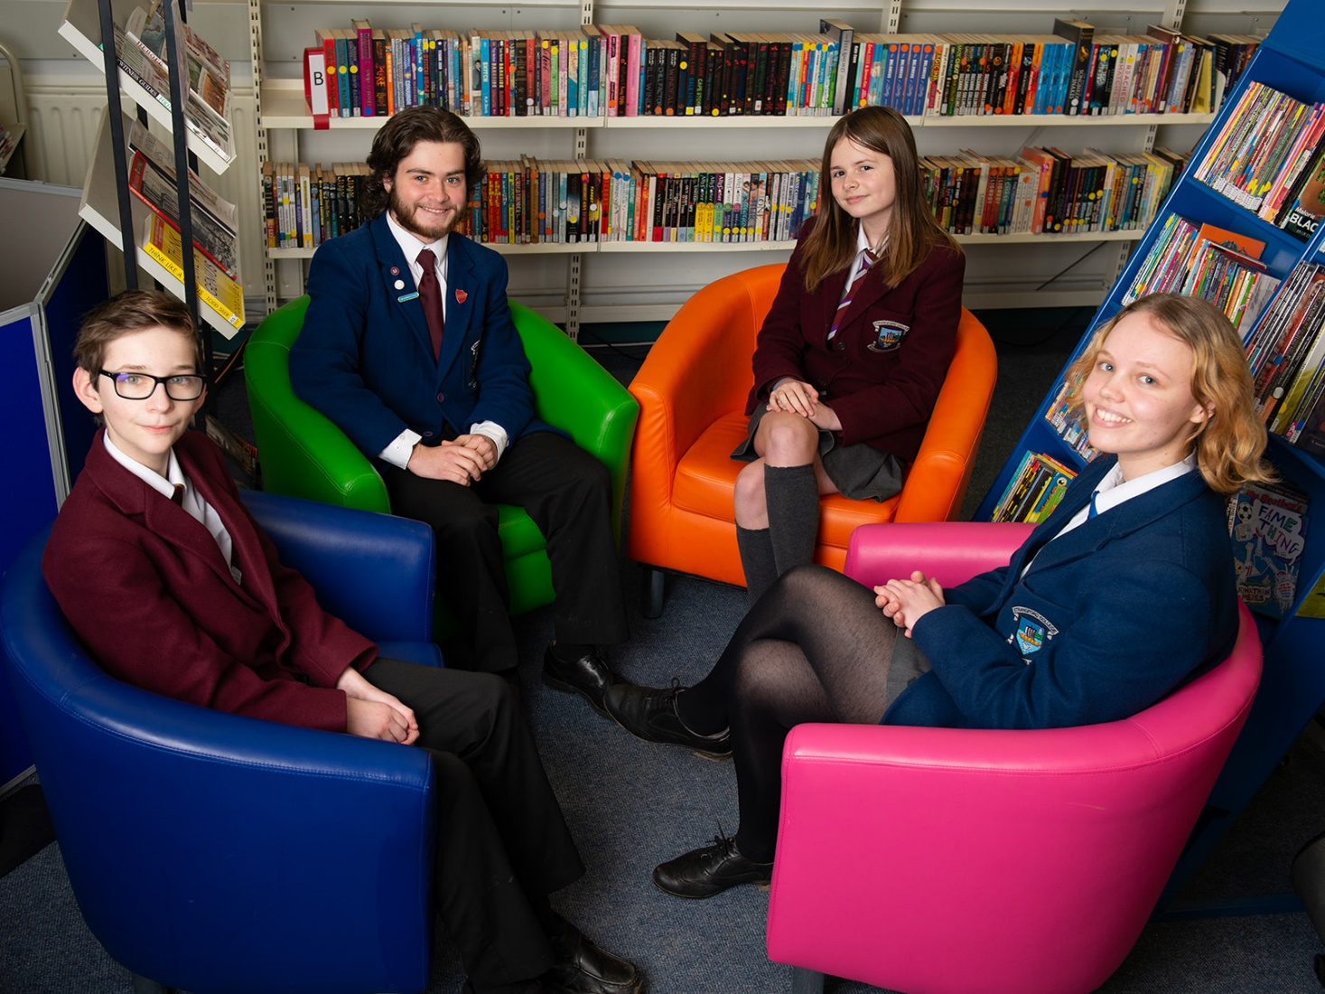

Internet Safety

Acceptable use of ICT
- Acceptable Use Student Form: this will enable your child to use the computer system and devices responsibly.
- They cannot go on the computer system until this is returned.
- Any irresponsible use of the school system or the Ipads will result in your child being sanctioned following our Behaviour for Learning Policy.

IPADS
- Students are given an iPad which is to be used sensibly and responsibly.
- This is for school work, homework and research for projects etc.
- It is up to each individual to ensure that their iPad is charged for each day in school and to look after it all times.
- If there is any damage to the iPad, it is the responsibility of the individual to pay for repair or replacement.

Sims Parent App
- Sign and agree to the SIMS Parent App acceptable use policy and the Parental Access request form
- Download SIMS Parent App from Google Play or the Apple Store
- Sign in with the unique code provided by the school using a third party account such as Google, Facebook, Twitter or Microsoft account

